**Final assignment**

**1st step:**

I have cloned the github by copying this url and running the command on cmd:

git clone https://github.com/Workearly/Final-Assignment.git

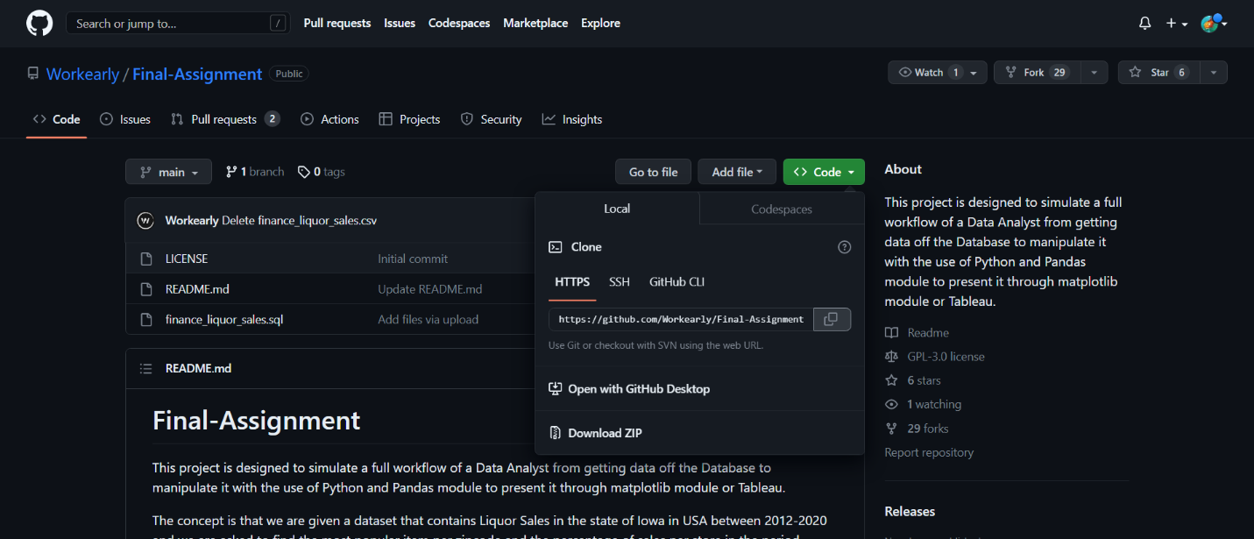

**2nd step:**

Run of the code provided, to create the database:

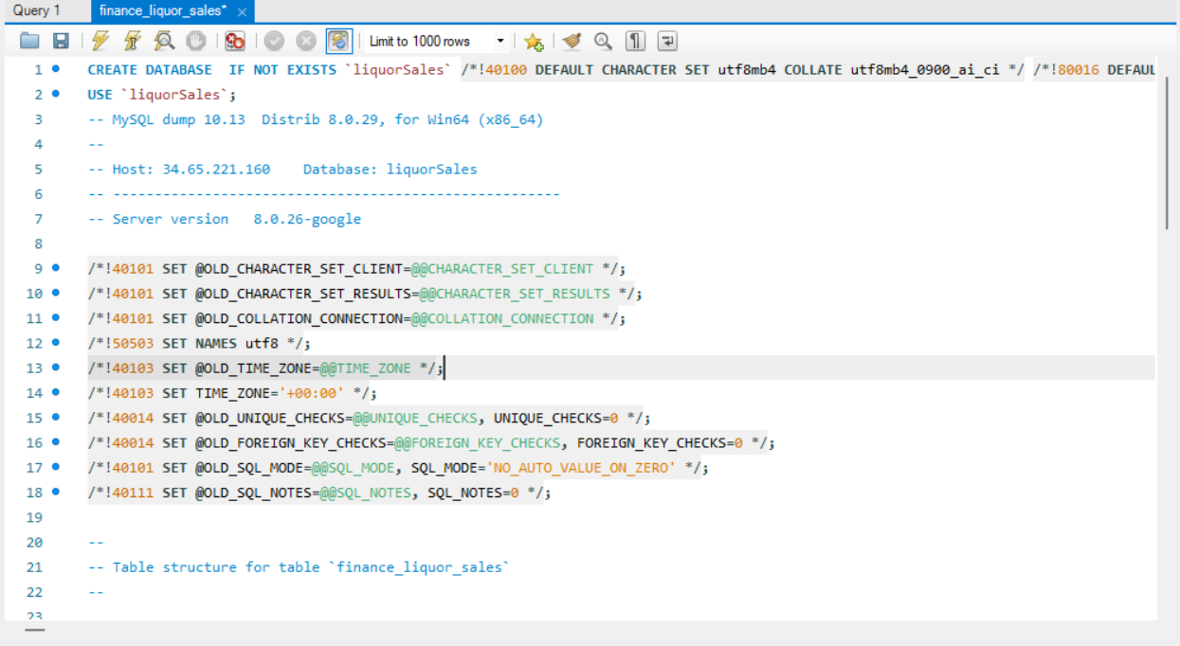

**3rd step:**

Querying the database for sales between 2016 and 2019. Export of the results to csv.

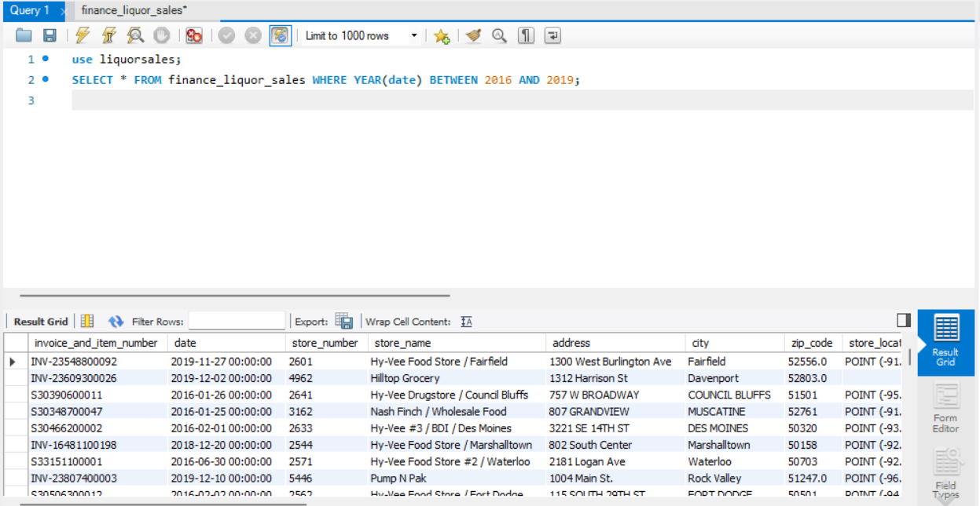

**4th step:**

Creation of a py file. Import of the required modules. Read the exported csv file. Group of the data dataframe by zip_code and item_description

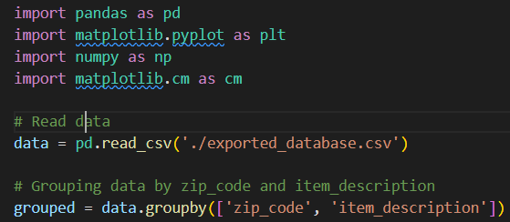

**5th step:**

Calculation of the total sales per store and the percentage of sales for each item by find the total bottles sold per zip_code and item_description and then by calculating the percentage of the bottles for each item_description sold from the total of the bottles_sold per zip_code. Discovering the most popular item sold by finding the index of the maximum per zip_code. Calculation of the total bottles sold per zip_code for the most popular item. Calculation of percentage of bottles per store_number.

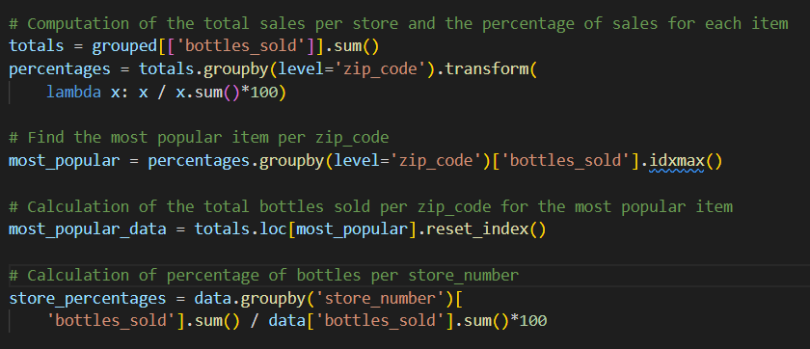

**6th step:**

Creation of a chart with 3 subplots. I chose this way to create something like a report.

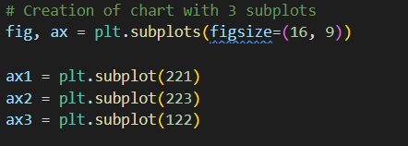

**7th step:**

Creation of a Scatter chart of bottles_sold for the most popular item per zip_code (upper left plot). I selected this type of chart to cover the chart presented in the initial github page. The modification here, is the rainbow palette in order to have the feeling of the low and high values. I also fixed the xticks to be every 500 by adjusting it to the nearest 10000.

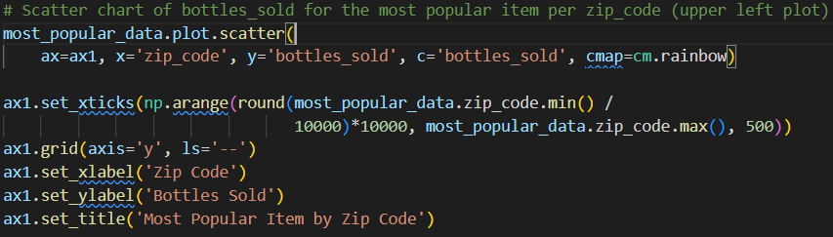

**8th step:**

Creation of a table presenting the data for the most popular item sold per zip_code. I did that by the creation of a subplot where the axes were off. Then I use the ax.table( function and I created this table with an automatic font and column sizing. This table is limited to preview only the top 10 items more sold bottles. In addition, I formatted header to be bold and I formatted the right column to get a different color based on its value into 4 categories. Also, I set the color of the font to be white only for the highest category.

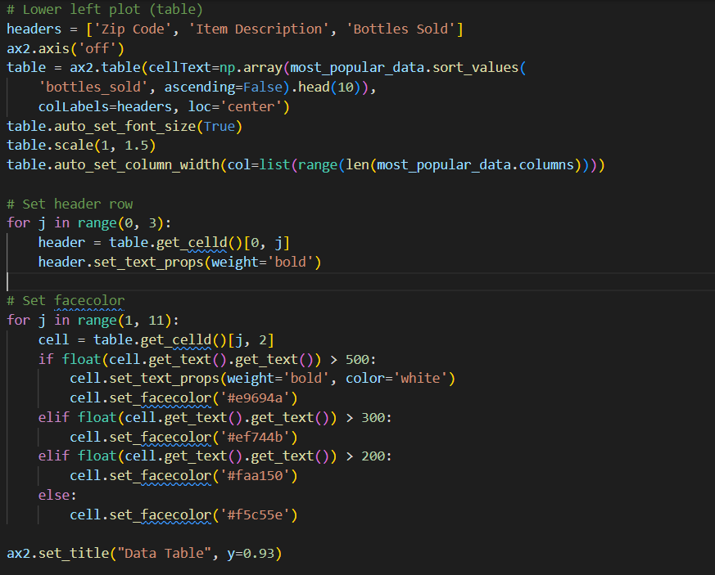

**9th step:**

Creation if a horizontal bar chart of percentage of bottles per store_number (right plot). I have set the colors to be generated based on the YlOrRd palette and the store_percentages_values. I also annotated a text that shows the percentage of Bottles sold per store.

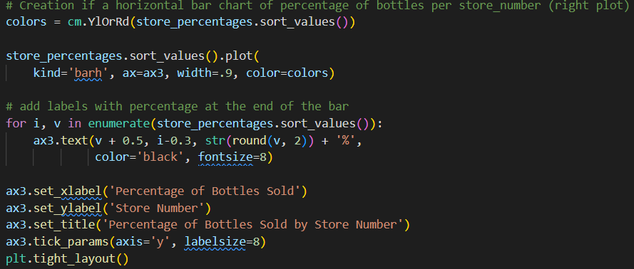

Για την συγγραφή του report επιλέχθηκαν εικόνες με High contrast ratio και κείμενο χωρίς πλήρη στοίχιση για άτομα με accecibility issues.